# Environment Used:

Downloaded the mavn project from the below link:

<https://www.journaldev.com/3531/spring-mvc-hibernate-mysql-integration-crud-example-tutorial>

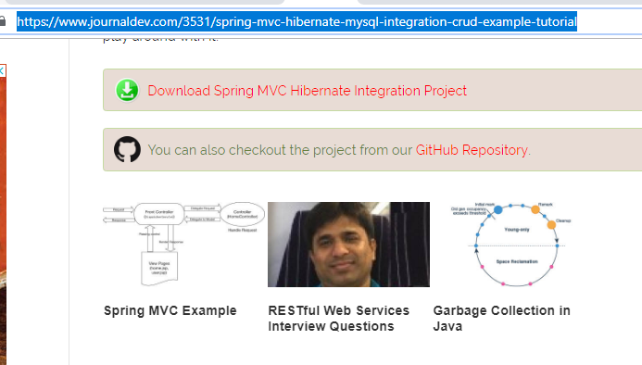

Then imported the project as maven project into the oxygen eclipse



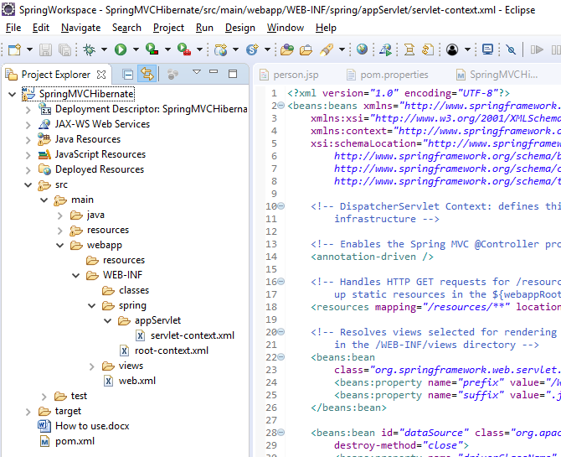

Mysql used version:

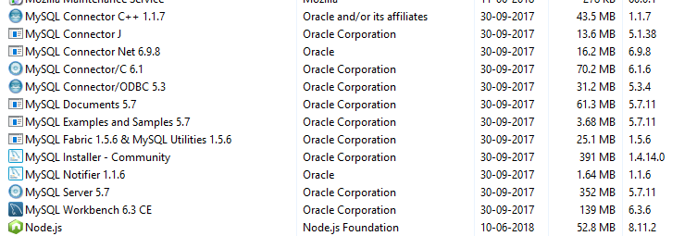

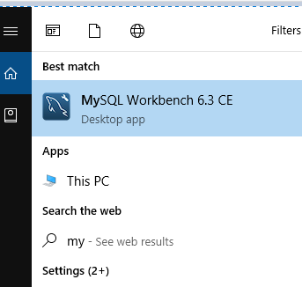

Tomcat used:



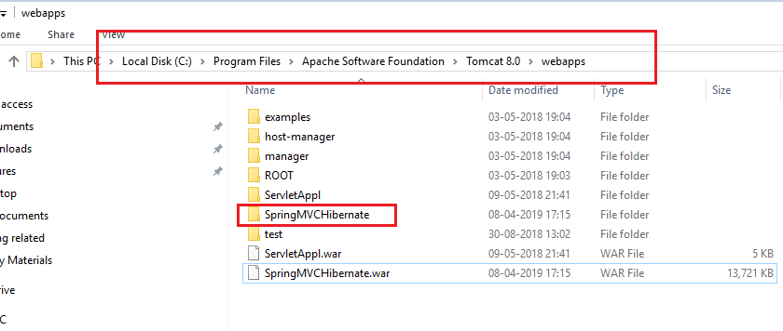

Oxygen Eclipse:

